AI System Latency Budget & Reactive Scaling Architecture
Production Performance Reference
Prepared by: Vipin Kumar

1. Latency Budget by Pipeline Stage
Target latency thresholds per stage across p50, p95, and p99 percentiles. The total pipeline row accounts for per-stage sums plus overhead and tail stacking.

Pipeline Stage | p50 | p95 | p99 | Why
Embedding | <100 ms | <200 ms | <400 ms | Small work, low variance
Retrieval | <200 ms | <400 ms | <800 ms | DB / network adds delay
LLM Inference | <1000 ms | <2000 ms | <4000 ms | Heavy compute, dominant latency driver
Total Pipeline Base | <1300 ms | <2600 ms | <5200 ms | Pure sum of stages
Total Pipeline (With Overhead) | <1500 ms | <3000 ms | <6200 ms | Base + system overhead (10-20%) + tail effects
Key Rules
- Sequential: total latency = sum(stages) + overhead
- Parallel: total latency = max(stage) + overhead
- Typically, p95 ≈ 2x p50 (normal variance under load)
- Typically, p99 ≈ 2x p95 (tail amplification due to retries, cold starts, queueing)
- If p95 > 3x p50 tail latency problem exists
- LLM Inference drives ~70–80% of total latency optimize p95/p99 first
- p99 is early signal of system instability before error rate increases

2. Latency Budget Framework
The framework behind how budget numbers are derived, validated, and applied. Percentiles do not compose linearly - always measure end-to-end in addition to per-stage.

Category | Formula / Value | Why | Example | Budget Standard
Stage Budgeting | p50 / p95 / p99 per stage | Break system into controllable parts | Retrieval p95 = 400ms | Define per stage SLOs
Total (Base) | Sum of stage latencies | Ideal sequential execution (no overhead) | 1300ms | Baseline reference
Overhead | Network + serialization + orchestration | Adds variability, impact increases at higher percentiles | API gateway + JSON = 150ms | Typically:  p50+~10%, p95+~15%, p99+~20%
Total (With Overhead) | Sum of stages + system overhead (10–20%) + tail effects | Accounts for real system overhead and variability | 1300ms 1500ms | Typically:  p50+~10%, p95+~15%, p99+~20%
Total (actual) | Measured end-to-end latency | Percentiles do not compose linearly | Measured end-to-end p95 ≠ sum of stage p95 | Always validate separately
Dominant Stage | LLM (~70–80%) | Drives overall latency and tail behavior | 2000ms of 2600ms | Optimize p95/p99 first
Tail Latency Rule | p99 >> p95 | Compounding: retries, queueing, cold starts | p95 = 2600ms Typically p99 ≈ 5200ms+ (tail amplification) | Typically: p99 ≈ 2x p95 (tail amplification)
Early Signal | p99 increase | Indicates instability before failures | p99 rises before error rate | Monitor proactively
Parallel Rule | max(stage) + overhead | Slowest parallel stage dominates execution time | max (400, 2000) + overhead ≈ 2200-2400ms  (dominated by LLM) | Budget around max stage
Sequential Rule | sum(stages) + overhead | Execution latency accumulates step-by-step | 100+200+1000 + overhead ≈ 1450–1550ms | Sum of all stages
Note: Budgeted latency represents estimated planning targets. Actual latency must be validated using end-to-end measurement, as percentile values do not compose linearly.

3. Metric Priority by Environment
The most important latency percentile shifts as you move from development toward production, reflecting increasing traffic and real user impact.

Environment | Key metric | Why it matters
DEV | p50 | Focus on correctness, latency outliers are acceptable.
QA | p95 | Tests realistic load, catches slow paths early.
SIT | p95 | Components tested together - integration bottlenecks surface.
UAT | p95 + p99 | Real business users testing - tail latency starts affecting user experience.
STG | p95 + p99 | Production mirror - tail latency predicts real user impact.
PRD | p99 | 1 in 100 users at scale = thousands of people. Primary signal for SLO violations, every outlier impacts real users at scale.

4. Key Design Rules
- In this reference model, p95 ≈ 2× p50
- p99 ≈ 2× p95 (tail amplification; may exceed under stress)
- If p95 > 3× p50 investigate tail latency issues
- LLM Inference drives ~70–80% of total latency optimize p95/p99 first
- Sequential pipelines total latency = sum(stages) + overhead
- Parallel pipelines total latency = max(stage) + overhead

5. Reactive Scaling Architecture
The diagram below shows the full reactive architecture for the AI service, including per-stage latency budgets, reactive responses, Kubernetes HPA configuration, and rollback decision logic.

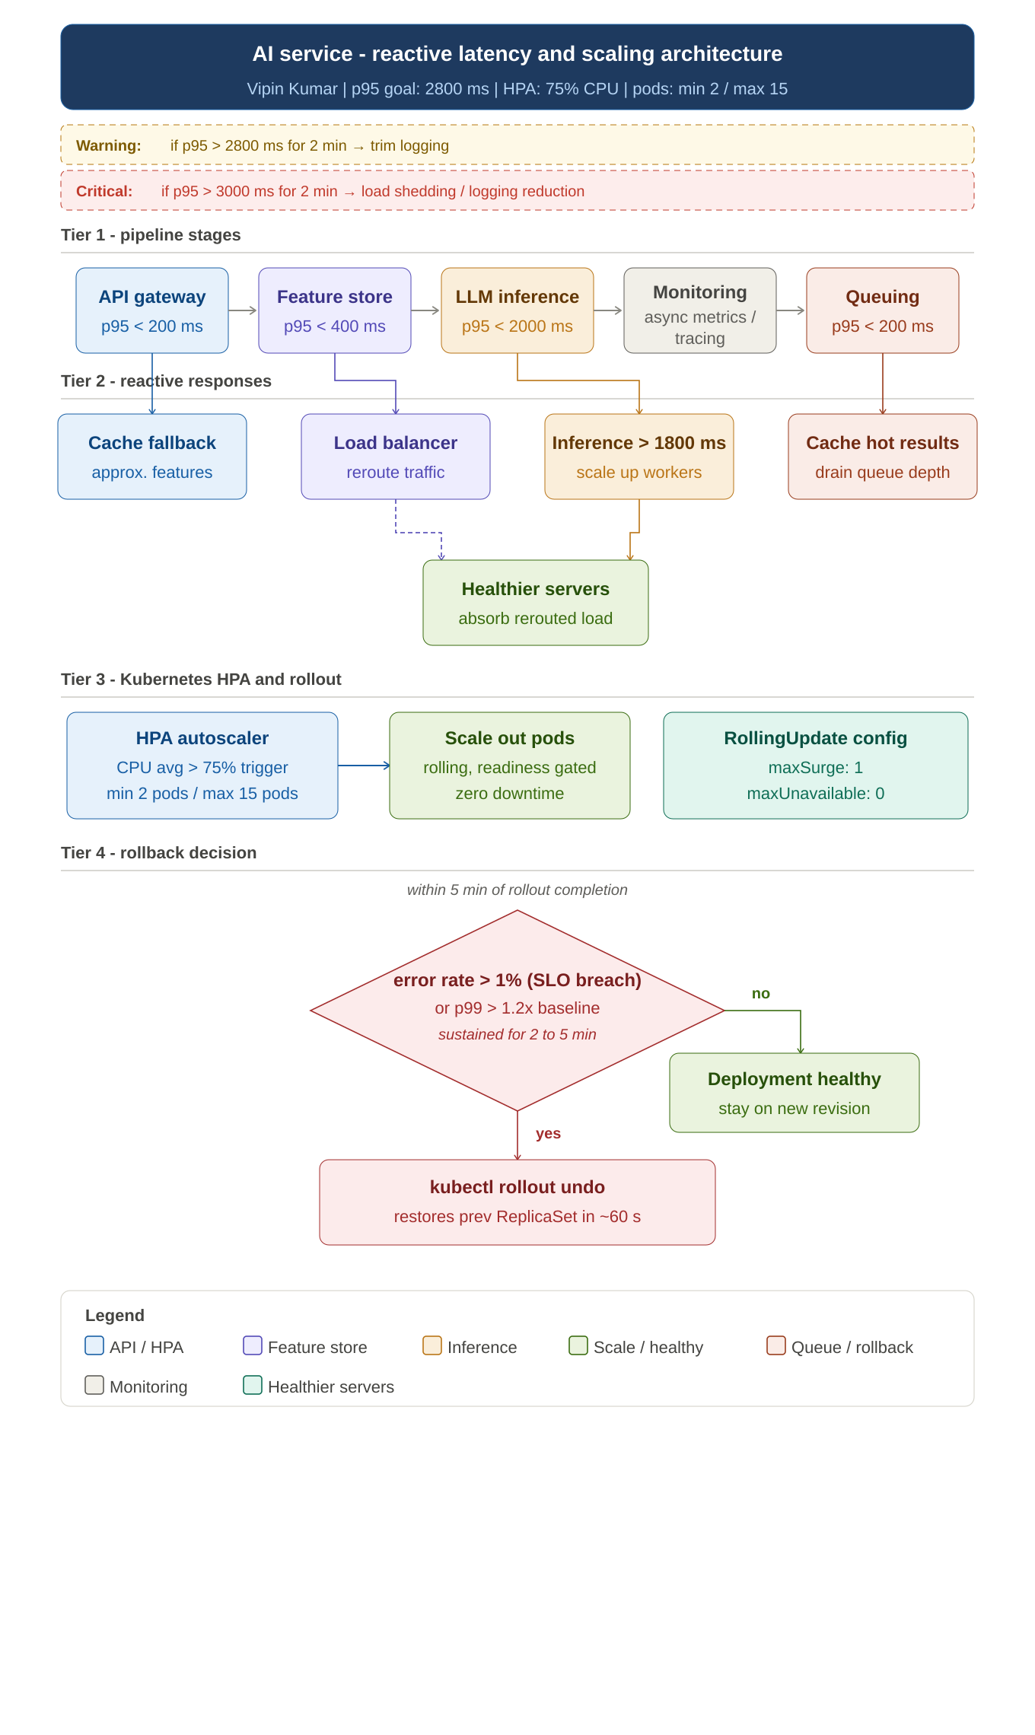
Figure 1. AI Service – Reactive Latency and Scaling Architecture

